PlasmaTube
Control app and modulator for large plasma tubes
Large tubes 200 × 1500 … 250 × 2000 mm · User Manual · TeslaCoilPro
Document version 2.1 · July 2026 · app 1.2+ · Android 8+

NOTE. The Russian and English editions are equal in status and describe the same app version.

Quick start
From box to sound-reactive light in seven steps.
- Power up the tube per its main manual. The modulator is powered from the tube's supply and starts with it.
- Install the PlasmaTube app (Android 8 or newer) and grant Bluetooth access.
- Devices → Add device. A “PlasmaTube_XXXX” entry appears — select it.
- Enter your home Wi-Fi name and password (2.4 GHz only) and send. The tube shows up in the list as online.
- Control tab: raise Power to 50–70 % — the tube lights up. Raise Depth to add a pulse.
- Music tab: grant the microphone and tap AUDIO ON. Play music — the tube follows the sound.
- Happy with a look on Control? Save on Device — the tube boots with it without the phone.
WARNING. If it doesn't work: the phone and the tube must be on the same 2.4 GHz Wi-Fi network; turn off any VPN on the phone (or add PlasmaTube to its exceptions); allow ~30 seconds after powering the tube on.

TIP. Guide items with a → arrow open the right screen and highlight the control they describe.

How it works
The phone never drives the glass directly — there are two links in between.
- Phone — PlasmaTube app
- 2.4 GHz Wi-Fi — local network
- Modulator — unit in the tube's supply
- Plasma tube — physical discharge
The modulator receives commands over Wi-Fi and smoothly controls the energy fed into the discharge: less energy — a dimmer, thinner glow; more — brighter and denser. The app streams brightness commands dozens of times per second, so the tube can breathe, pulse, and flash in time with music.
Sound-to-light latency is a few tens of milliseconds — flashes land on the beat to the eye. One phone controls any number of tubes at once, and each can be given its own character.
NOTE. A tube also works without a phone: the modulator remembers the last saved mode and plays it back on its own. If the command stream stops, the tube reverts to its saved mode within a few seconds.

NOTE. Availability by size: the modulator ships with the large tubes — 200 × 1500, 200 × 2000, 250 × 1500 and 250 × 2000 mm. The 90 × 900 mm tube ships without a modulator by default: physical control only — the circuit breaker and, if fitted, the power dial. For other sizes, check the configuration with the manufacturer.

Safety
A two-metre electrical object deserves a clear perimeter.

Keep it upright
A level, stable, non-flammable surface. Carry by the base, not the glass, with enough people to keep it vertical.

No touching when energized
Glass, base, cable, connectors and controls — only with power removed. Keep children and animals away.

Dry and ventilated
No rain, fog, condensation or wet floors. Never block ventilation or cover the base.

EMI zone
The HF discharge produces significant interference. Keep away from pacemakers, medical and measurement gear, electronic fire detectors.

Strobe notice
The Strobe and Beats profiles and a high Speed setting can trigger seizures in photosensitive people. Warn the audience.

Stop if wrong
Switch off immediately on a crack, smell, smoke, overheating, abnormal sound, unstable arcing or cable damage.

Power sequence: physical first, app second
- Circuit breaker OFF / 0; the physical dial (if fitted) at minimum.
- Connect the supplied cable to the base, then to a sound wall outlet.
- Switch the breaker ON.
- Slowly raise the physical dial until the discharge is stable. If the tube flickers, the power is too high — back it off.
- Only after the physical discharge is stable, connect the app and raise Power.
WARNING. Emergency stop: Blackout in the app first, then the physical breaker. Pulling the plug is for emergencies only.

Control | What it limits | How to use it
Physical dial (if fitted) | The supply's energy ceiling | Set a stable ceiling; never buy brightness with flicker.
Power in the app | Current brightness below the physical ceiling | Start at 50–70 %, then add movement with Depth.
Blackout in the app | An immediate zero-output command | Kills the light fast; for physical isolation use the breaker.

LIABILITY. All activity involving this device is at the user's own risk. TeslaCoilPro is not liable for direct, indirect or consequential damages arising from use or misuse. The user is solely responsible for compliance with local laws and regulations. This is an experimental RF device; no CE, FCC or other certification is claimed.

Control — manual operation
The phone computes the light waveform and streams it to the tubes live.
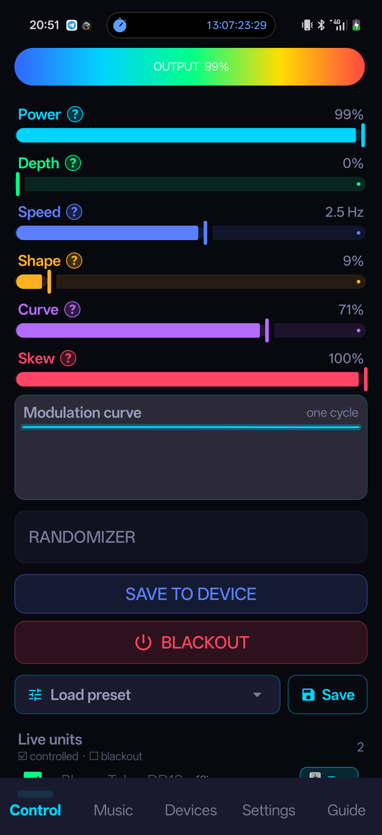
Control — manual waveform control
Control | What it does
Power | Base brightness. 0 % = off. The pulse dips below this level.
Depth | How deep each pulse dips below Power. 0 % = steady glow.
Speed | Pulse rate — from a slow breathe to a fast flicker. Shows real Hz; the ceiling depends on Signal Rate in Settings.
Shape | Smooth ↔ sharp transition between peaks.
Curve | Soft ↔ punchy response (gamma).
Skew | Pulse asymmetry: a sharp attack with a gentle fall — or the reverse.

- Randomizer — wanders the parameters around your set values; turning it off restores them.
- Blackout — instantly drops power to zero; tapping again restores it.
- Save on Device — writes the current look into the tube's memory for autonomous playback.
- Presets — save and load your own setups; factory presets included.
The units list at the bottom: checked means the tube is controlled; unchecked is a blackout for that tube alone (it goes dark but stays controlled). The 🎚 Tune chip opens per-tube tuning.

Music — sound-reactive light
The phone's microphone → spectrum analysis → real-time tube brightness.
At the top: the AUDIO ON / STOP buttons; while audio is live, that pair stays pinned on every tab. Below: the Basic | Pro | Live sub-modes and a live spectrum (31 Hz … 8 kHz). Audio keeps running when the app is backgrounded.

Basic — set it and forget it
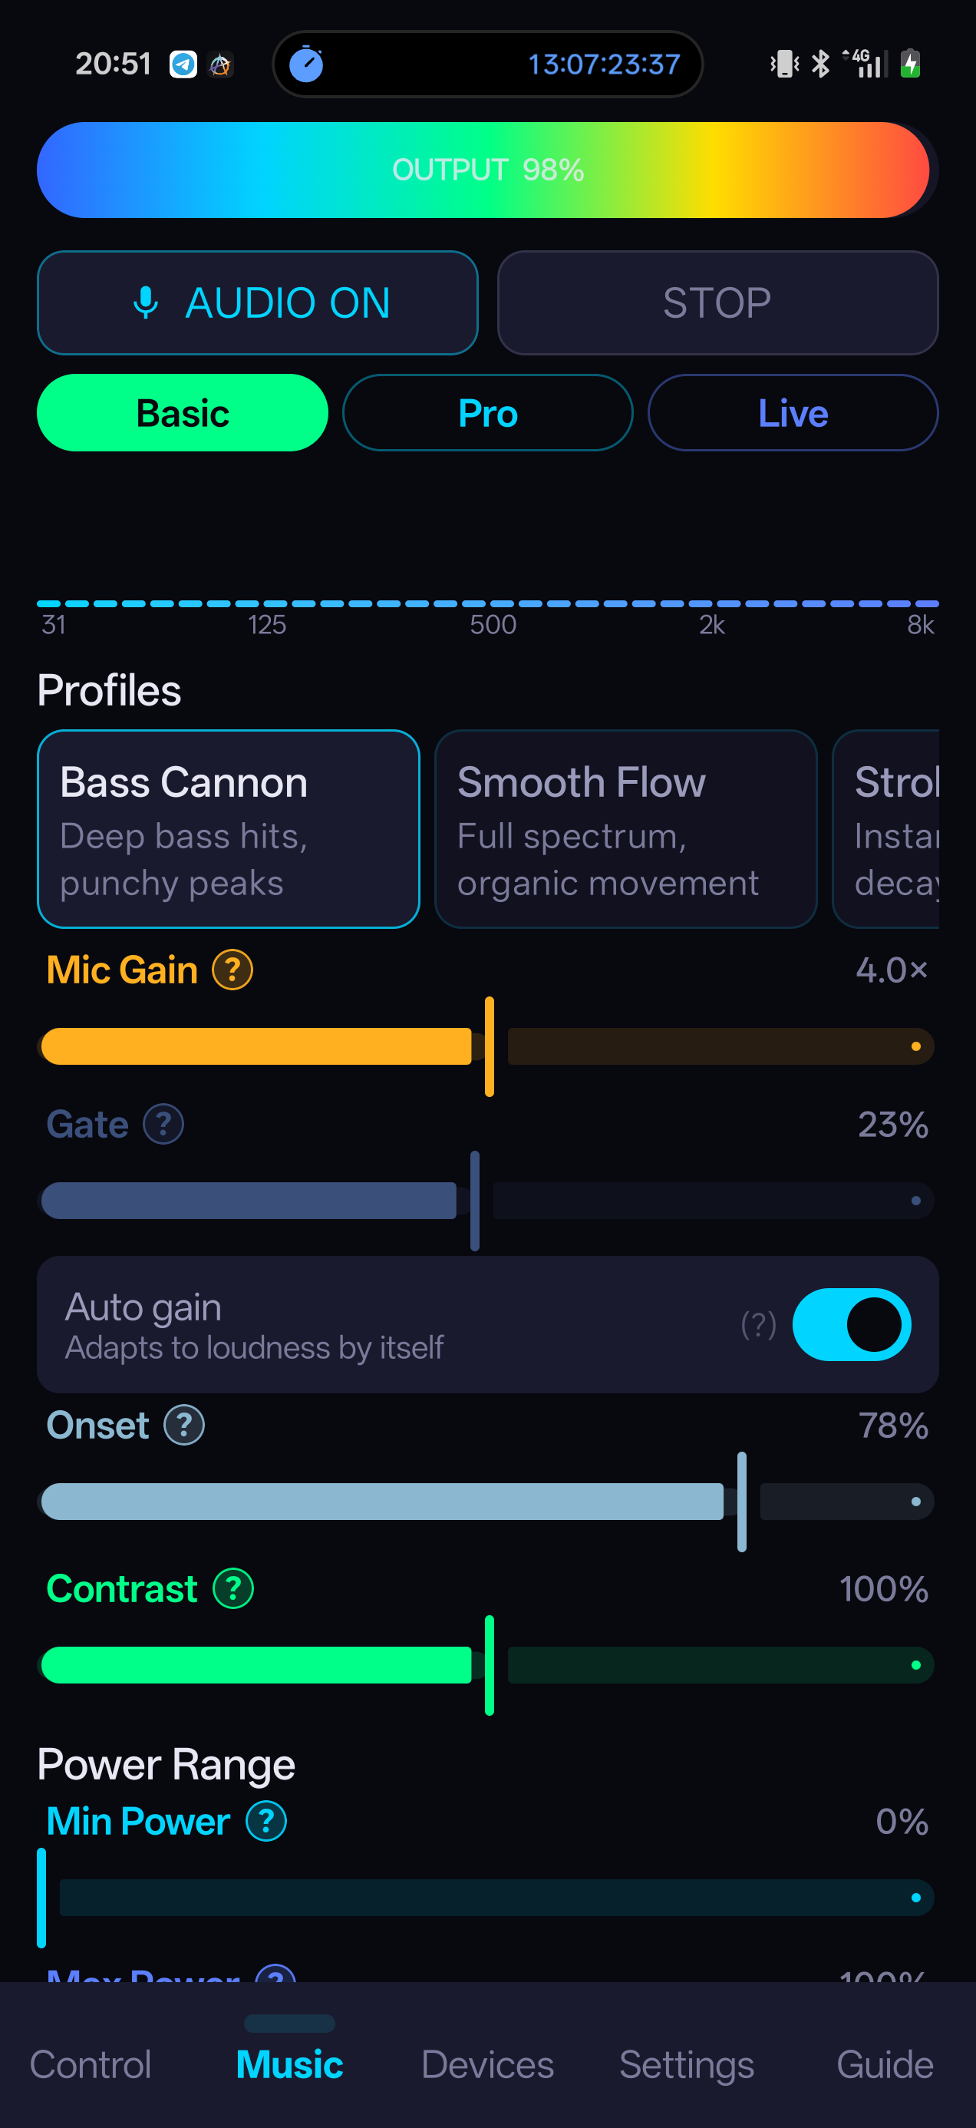
Music · Basic — profiles and the main controls
Profile | Character
Bass Cannon | Deep bass, punchy peaks.
Smooth Flow | Full spectrum, organic movement. A good starting point.
Strobe | Instant flash, tight decay.
Ambient Glow | Warm background, gentle breathing — the tube never goes dark.
Beats | Strictly on the beat: the tube flashes on beats, loudness doesn't matter.

Control | What it does
Mic Gain | Real microphone sensitivity (×0.25…×60). Low — only loud and close; high — catches quiet sound from afar (and room noise — raise Gate then).
Gate | Silence threshold: anything quieter won't light anything up. Raise it if background noise twitches the light.
Auto gain | ON — the app adapts to loudness itself. OFF — manual: Mic Gain alone sets brightness. Better for a stable stage level.
Onset | A separate reaction to sharp hits (kick, snare): the light jumps straight to max. 0 = off.
Contrast | How contrasty the light follows the music: left — steady glow, mid — natural breathing, right — flashes on peaks only.
Min / Max Power | The range brightness moves within. Max reaches 150 % — overdrive.

NOTE. Overdrive (>100 %): actual output still caps at 100 %, but the top of each pulse holds peak power longer. Useful for slow gas mixes that can't flare up on a short hit.

The Beats profile
The light follows the beat grid, not the loudness: the app tracks tempo and flashes exactly on the beats — even over a sustained pad. Locking the tempo takes a few seconds of rhythmic material; on non-rhythmic sound it falls back to individual hits. Flash length is set by Release.

Pro — full access
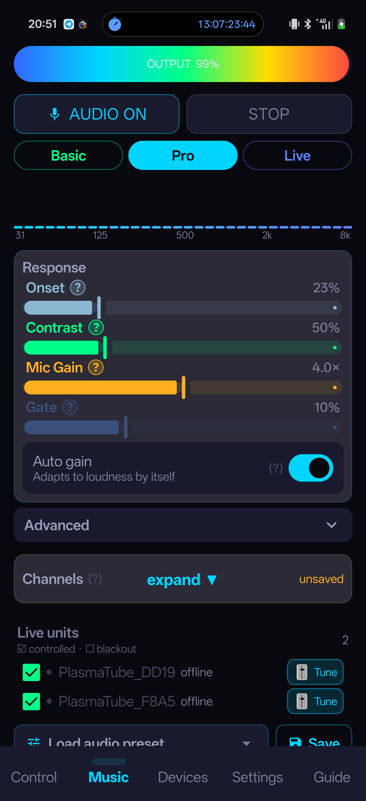
Music · Pro — the Response card
- The Response card: Onset, Contrast, Mic Gain, Gate and the Auto gain toggle.
- Advanced (expandable): Attack (1–500 ms — flare-up speed), Release (10–2000 ms — fade speed), Gamma (loudness-to-brightness curve), Min/Max Power (up to 150 %).
- Below that — the Channels block. Audio presets and the units list sit at the very bottom.

Live — gestural control
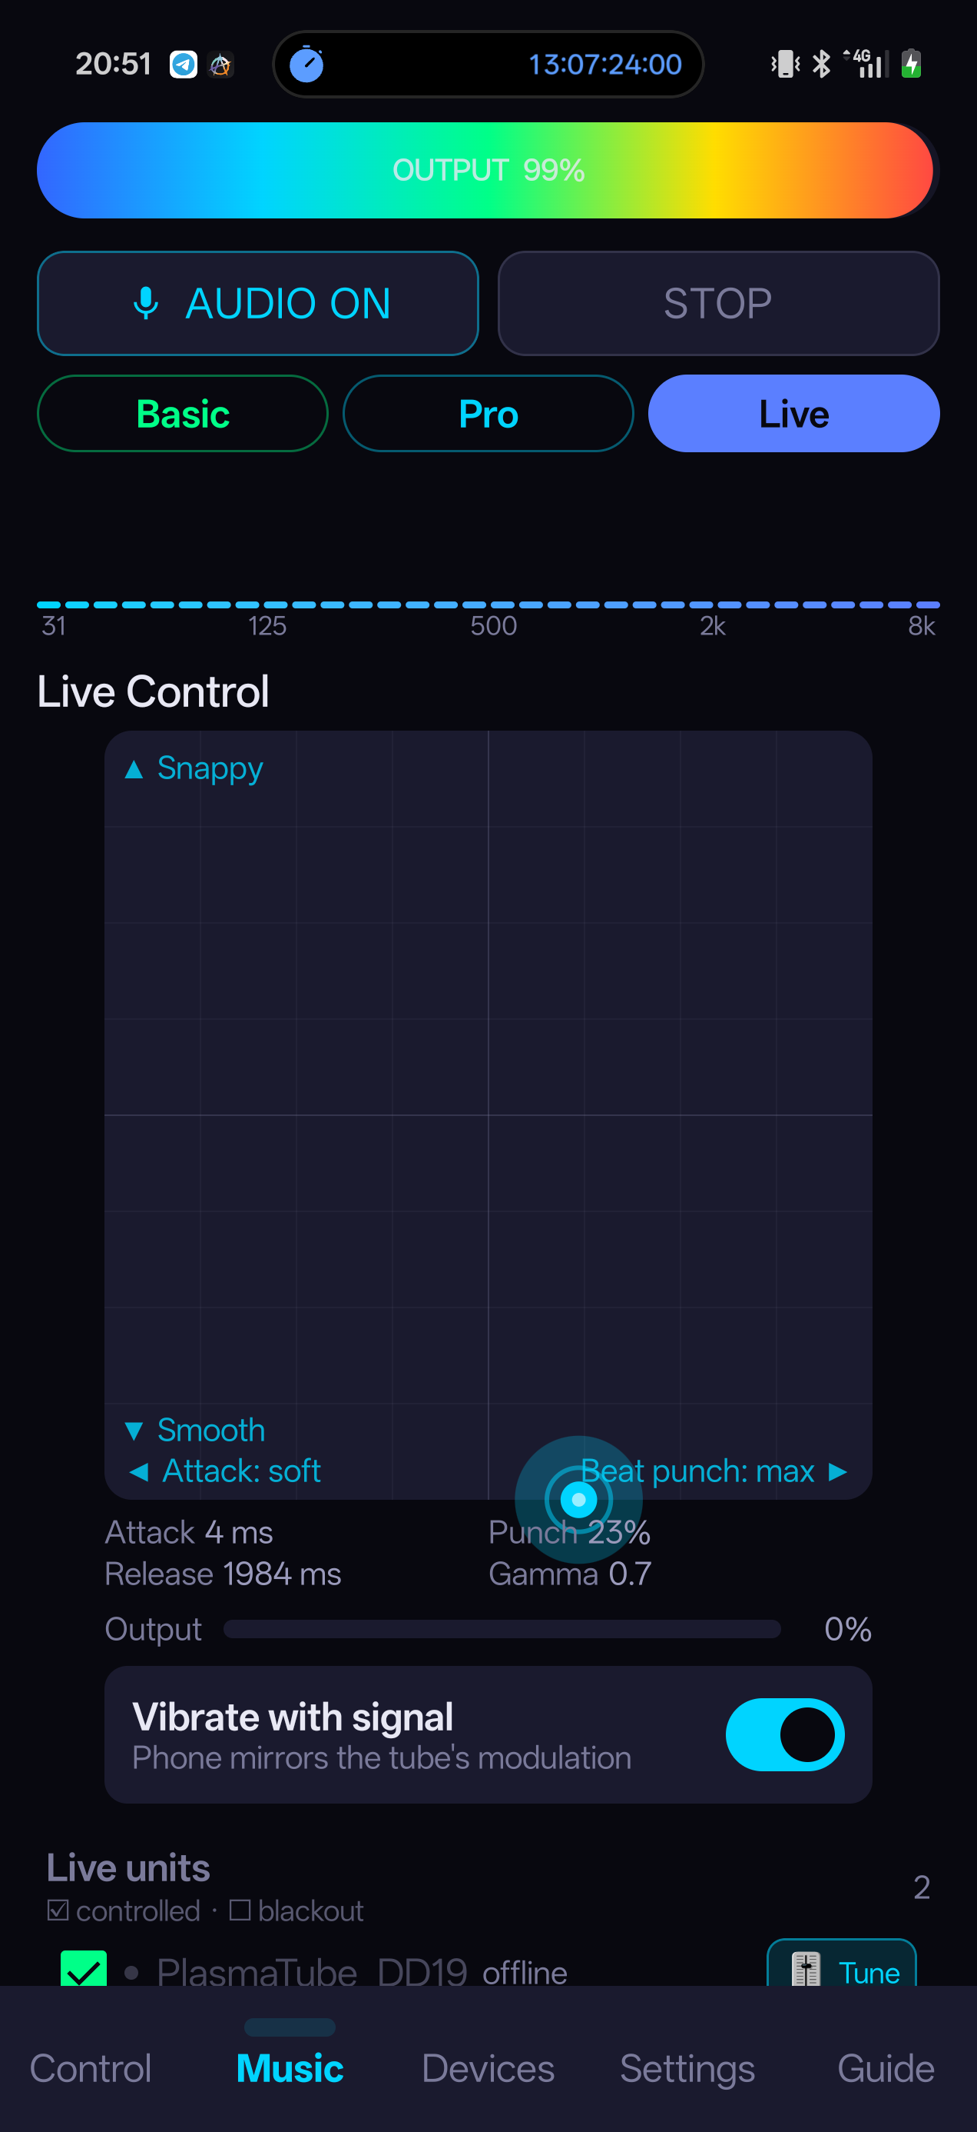
Music · Live — the XY pad
An XY pad: horizontal — Attack and Onset (left smooth, right sharp), vertical — Release and Gamma. Below it: the current values and an Output bar. A vibration toggle makes the phone buzz in sync with the tube — handy for tuning without looking at it.

Channels — tubes by frequency band
The ensemble splits the music: one tube on bass and beat, another on mids, a third on highs.
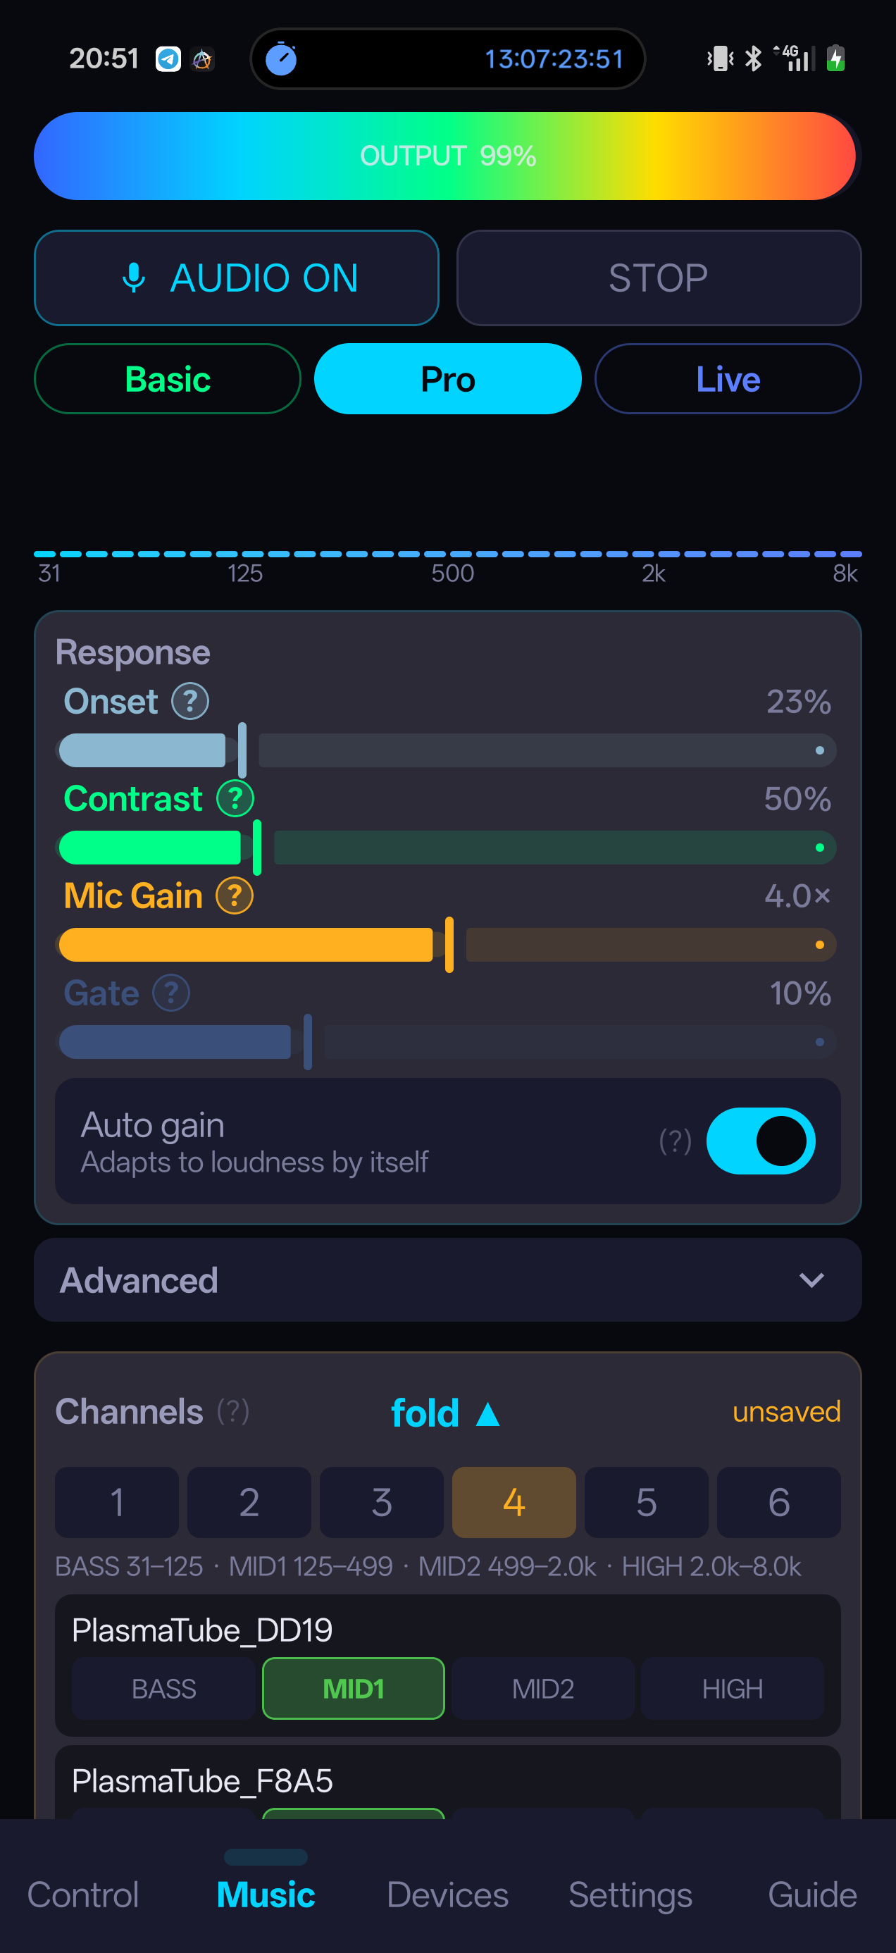
Channels — splitting tubes across bands
The block expands on a tap of its header. Pick a band count (1–6) and cells with band names — BASS, MID, HIGH… — appear next to each tube. Tapping a cell switches the tube immediately, live — listen and watch to find where each tube works best.
- Save — stores the layout (without saving, restarting the app reverts to the previous one).
- Reset (1ch) — puts every tube back on the shared signal.
- Band frequency ranges are shown above the table and live level bars inside the block. Empty bands are flagged with a warning.
TIP. A classic three-tube split: bass/beat on the brightest and fastest tube, mid on the bulk of the mix, highs on the most nervous one.

Devices and tube settings
Bluetooth pairing once — then control over the local network.
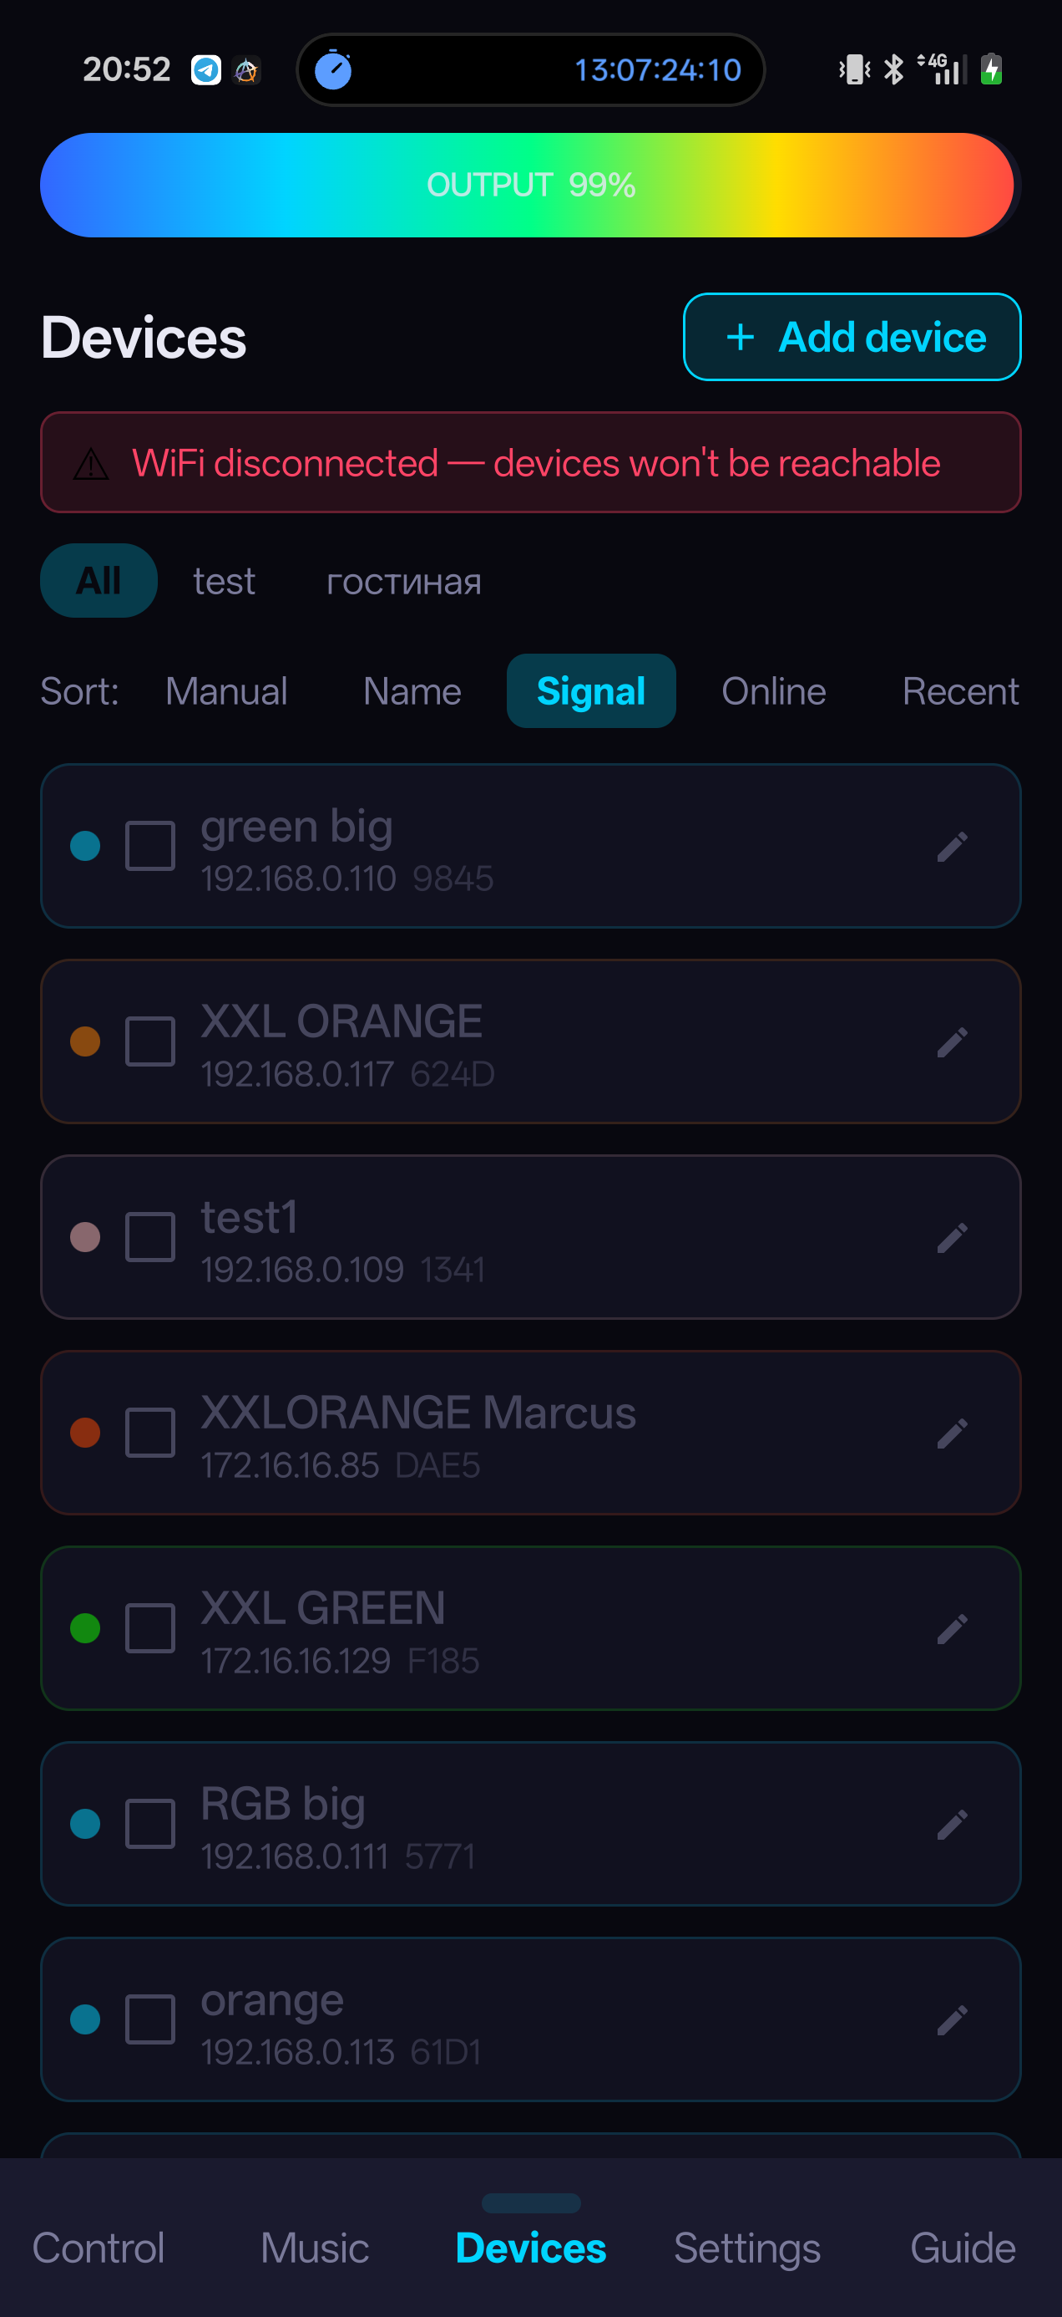
Devices — the tube list

Connecting a tube to your network
- Power the tube. An unconfigured modulator broadcasts a “PlasmaTube_XXXX” Bluetooth beacon (XXXX = the last 4 characters of the board address, also on the enclosure label).
- Devices → Add device. If Bluetooth is off, the app offers to enable it.
- Select your tube from the list.
- Enter the network name (SSID) and password. Case matters. The network must be 2.4 GHz.
- Send. The tube joins and appears in the list; a newly added tube is pinned to the top.
NOTE. Wi-Fi credentials are remembered — the next tube takes two taps. A configured tube's beacon is off; “Forget Wi-Fi Network” in the tube's settings turns it back on.

The tube list
- Each card shows: name, IP, ID, a colour-coded signal indicator and status. The checkbox means “controlled by the app”: an unchecked tube runs autonomously.
- Groups — combine tubes and control a subset.
- Sort: manual (drag) / name / signal / online / recent. The order never jumps on its own — re-sorting happens only via ↻. A new tube stays pinned on top until the first ↻.

Tube settings
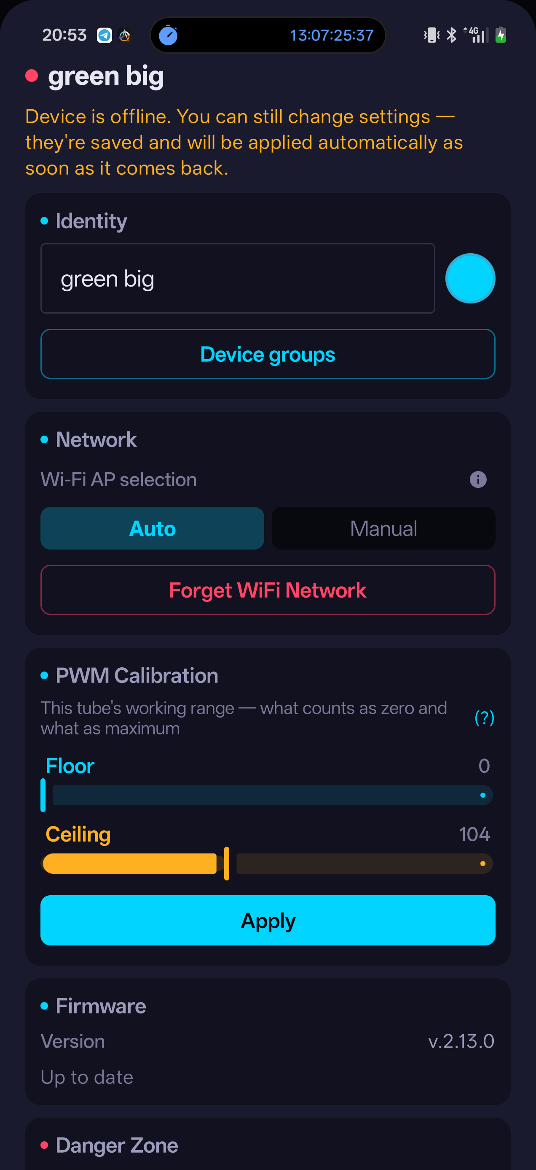
Tube settings and PWM calibration
Opened from the card's pencil. They work for an offline tube too: changes are queued and applied as soon as it reconnects.
- Name and colour — the colour hides behind a swatch next to the name and is used as a UI accent.
- Wi-Fi AP — Auto (the tube picks the best AP, recommended) or Manual (pinned to one AP — for networks with a repeater). “Forget Wi-Fi Network” resets to first-time setup.
- PWM Calibration — this tube's own working range (below).
- Firmware — version, over-the-air update and rollback to the previous version.

PWM calibration
Every tube strikes and saturates at its own level. Calibration stretches the app's entire slider travel across exactly that range.
- Set Floor to 0 and raise it until the tube glows steadily.
- Raise Ceiling to your desired brightness cap.
- Tap Apply. The values live in the tube's own memory and survive a reboot and a change of phone.

Per-tube tuning
Different gas mixes respond differently to the same signal: one flashes instantly, another needs to wind up.
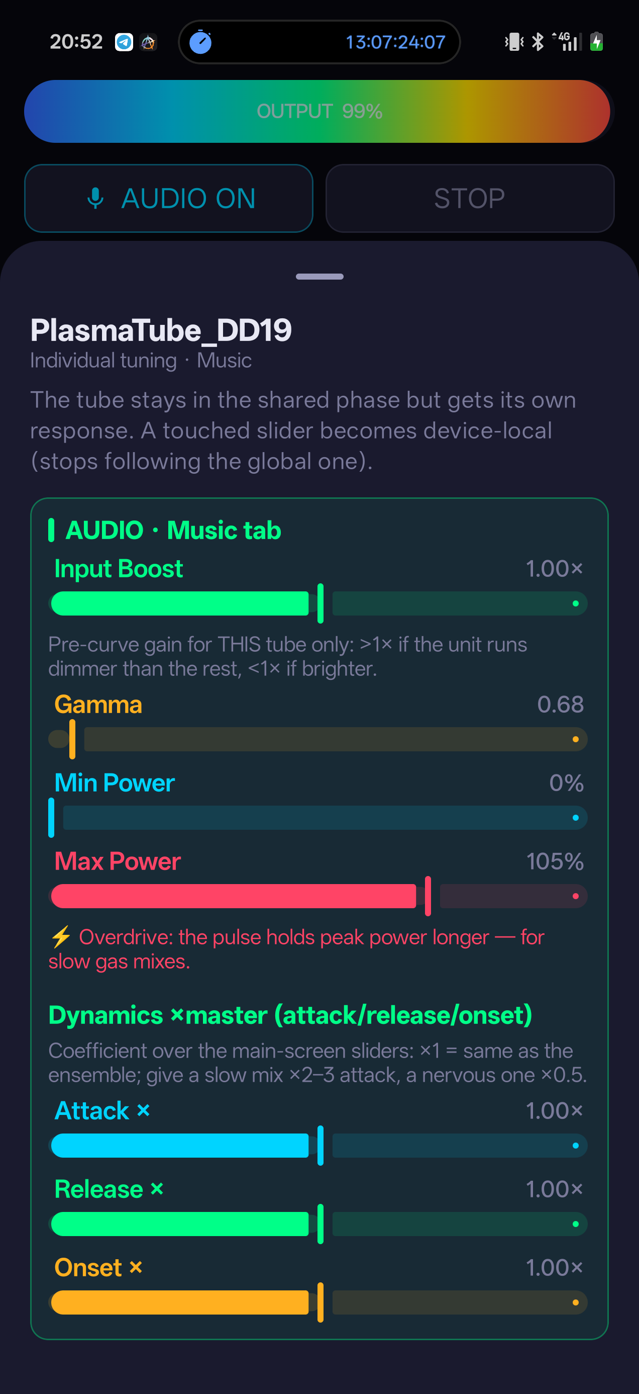
Per-tube tuning
Tuning gives each tube its own response curve while the ensemble stays in the shared phase and the main-screen sliders keep driving all tubes together. The 🎚 Tune chip lives in the units list at the bottom of Control and Music. Control opens the WAVE group, Music the AUDIO group.
Control | What it does
Power, Depth, Curve (WAVE group) | Personal values on top of the shared Control pulse.
Input Boost | Gain for this tube alone: above ×1 if it runs dimmer than the rest, below ×1 if brighter.
Gamma, Min/Max Power | This tube's own curve and brightness limits (Max up to 150 %, overdrive).
Attack ×, Release ×, Onset × | Coefficients over the master sliders (×0.25…×4, centre ×1): turning Attack on the main screen moves the whole ensemble; the coefficient only skews this tube relative to it.

- A touched slider becomes personal to the tube (marked with a dot) and stops following the master; untouched ones keep following.
- Reset clears only the visible group. A tube with active tuning is highlighted with an amber border in the list.
TIP. Recipes: a slow mix — Attack ×2–3 and Max 140–150 %; a nervous one — Attack ×0.5 and Onset ×0.25.

Settings and autonomous operation
App settings and the rules by which a tube lives without a phone.
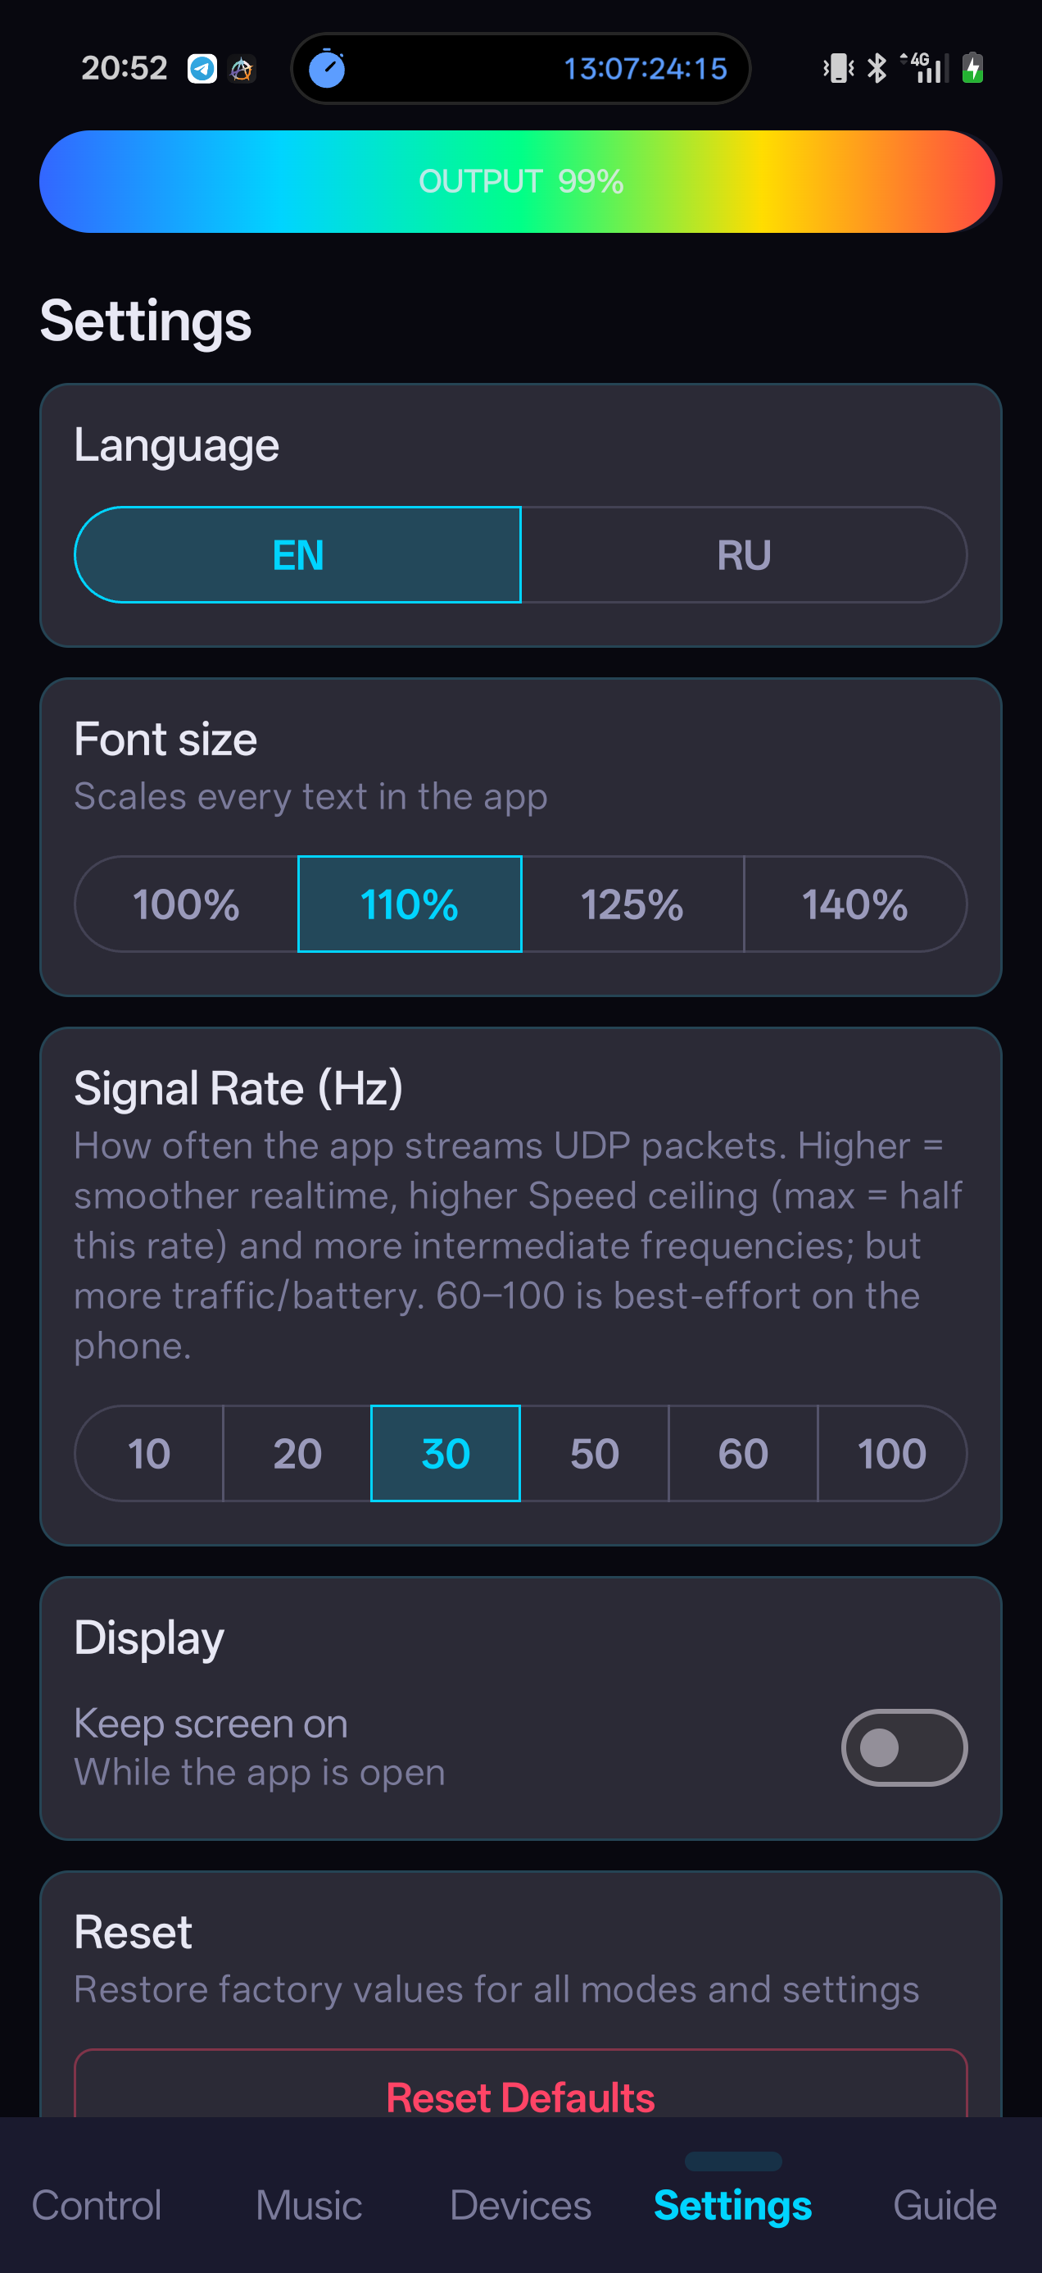
Settings
Setting | Description
Language | Russian / English.
Font size | 100–140 % — scales all app text, applies instantly.
Signal Rate (Hz) | How often the phone streams commands (10–100). Higher — smoother and a higher Speed ceiling, but more traffic and battery drain.
Keep screen on | The screen stays awake while the app is open.
Reset | Factory values for all app modes and settings (does not touch the tubes).
Advanced | Signal Transport (Art-Net/DMX — standard; Legacy UDP — direct) and Diagnostics — packet counters, signal strength and uptime per tube.

Autonomy and control priority
- Save on Device writes the current mode into the tube's memory; it boots with it without a phone.
- If the command stream stops, the tube reverts to its saved mode within seconds; when the phone returns, it follows again.
- The physical dial is a power ceiling above any command: at 50 % the tube never exceeds 50 %.
- Two phones: a tube follows whoever started streaming first and keeps that sender until it goes quiet for ~3 seconds. Blackout from a second phone always works — it is the emergency button.

Firmware updates
- Devices → the tube's card → the Firmware section.
- If a new version is available, tap Update. The tube downloads the firmware from the phone and reboots; this takes 1–3 minutes.
- Wait for the online status to return.
WARNING. Do not power off the tube during an update. If it doesn't come back, allow up to 3 minutes: a weak link makes confirmation slower, and on failure the tube rolls back automatically. A rollback button sits at the bottom of the section — the app always carries two versions.

Troubleshooting
Start with the symptom you can observe.
Symptom | Cause | Action
Tube doesn't light up | Power at zero / tube offline / physical dial | Raise Power; check the green status in Devices; check the dial and the supply.
Red status (no link) | Different networks / VPN / tube unpowered | Phone and tube on the same 2.4 GHz network; disable VPN; wait ~30 s after power-on.
Bluetooth finds nothing | Tube already configured / too far / permissions | “Forget Wi-Fi Network” re-enables the beacon; move within 10 m; grant permissions; power-cycle the tube.
Wi-Fi setup fails | Typo / 5 GHz network | Check the SSID (case-sensitive) and password; the network must be 2.4 GHz.
Audio not reacting | Mic denied / audio off / too quiet | Grant the microphone; tap AUDIO ON; raise Mic Gain, lower Gate; move the phone closer.
Light hovers and barely breathes | Contrast too low / floor too high | Raise Contrast; check Min Power.
Tube sits near full power | Contrast too low / onsets firing constantly | Raise Contrast; lower Max Power; pull Onset toward zero.
Light twitches from background noise | Noise passes the gate / auto gain pulls it up | Raise Gate; or turn off Auto gain and set Mic Gain manually.
One tube is dimmer or slower | Gas-mix difference, not a fault | 🎚 Tune: raise Input Boost; Attack ×2–3; Max above 100 %.
A tube stays silent on its band | No music energy in that range right now | Expand Channels, watch the live bars; tap another cell — the switch is instant.
Text is too small | — | Settings → Font size → 125–140 %.
Update stuck on Rebooting | Slow Wi-Fi reconnection | Wait up to 3 minutes, don't power off; on failure the tube rolls back on its own.
Tube ignores you after a second phone | The “first sender” rule | Stop the stream on the other phone and wait ~3 seconds.

Frequently asked questions
Q: Does the tube work without a phone?
A: Yes. Save a mode with “Save on Device” — the tube boots with it on its own. A phone is needed to change modes and for sound-reactive light.
Q: How many tubes can I connect?
A: The system is built for an ensemble; configurations of up to ten tubes at once have been tested.
Q: Where does the microphone audio go?
A: Nowhere. Analysis happens on the phone; audio is never recorded or transmitted — only brightness commands are sent.
Q: Why is a 2.4 GHz network required?
A: The modulator's radio only works on 2.4 GHz. A dual-band router is fine — what matters is that the phone and the tube can reach each other on the same LAN.
Q: Can I use my phone's hotspot?
A: Yes: enable a 2.4 GHz hotspot and configure the tubes onto it — the network and the remote live on one device.
Q: What does the physical dial do?
A: It sets a power ceiling above any app command. Handy for handing the phone to guests while keeping the maximum yourself.
Q: Does it work with DMX consoles?
A: Yes, the tubes accept Art-Net (DMX over the network). Pick the transport in Settings → Advanced.
Q: Can I update firmware during a show?
A: No. Schedule firmware work outside the show window, with stable power and time for a check.

Pre-show checklist
Worth printing for the operator's position.

Before the audience arrives
- ☐ The tube stands upright, stable and dry; no damage, no metal near the glass.
- ☐ Nobody in the room has a pacemaker or an implanted life-support device.
- ☐ Sensitive electronics and electronic fire detectors are outside the interference zone.
- ☐ The cable and breaker are reachable, ventilation is unobstructed.
- ☐ The phone and every tube are on the same 2.4 GHz network; VPN is off.
- ☐ Every tube shows online and the intended control state.
- ☐ Physical power is stable with no flicker; app Power starts low.
- ☐ For Music, the mic permission, Gate and Min/Max are checked on the actual sound system.
- ☐ Strobing effects are off or explicitly agreed for this audience.
- ☐ The operator knows where Blackout and the physical breaker are.

Normal shutdown
- ☐ Stop Music to end the microphone stream.
- ☐ Tap Blackout and confirm every tube is dark.
- ☐ Switch the physical breaker off.
- ☐ Return the physical dial to minimum.
- ☐ Let the base cool; inspect the cable and glass before moving.

Glossary
Term | Meaning
Modulator | The control unit in the tube's supply: receives Wi-Fi commands and controls discharge power.
Envelope (Attack / Release) | How fast the light flares up when sound appears and fades when it stops.
Onset | A sharp start of sound — kick, snare, clap.
Gate | A silence threshold: signal quieter than this doesn't light anything up.
Auto gain | Automatic adaptation to source loudness.
Band | A frequency range assigned to a tube in the Channels block.
Overdrive | Max Power above 100 %: the top of the pulse holds peak power longer.
PWM calibration | Mapping slider travel to a specific tube's real working range.
OTA | Over-the-air firmware update from the app.
Blackout | Instant dimming, restored with one button.

Contacts
- E-mail: info@teslacoil.pro
- Telegram: t.me/teslacoilru
- plasmatube.pro
Telegram is the preferred channel. A video call with a demo — by arrangement.

